ENTERPRISE PERFORMANCE
Hear my story, start your journey!

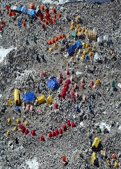
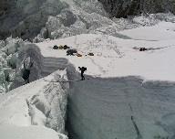
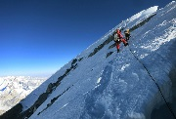
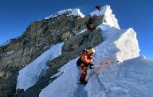
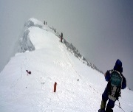
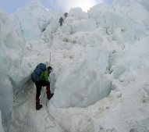
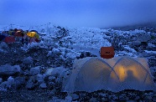
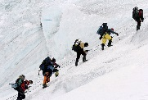
Enterprise Performance, really, becomes an integral part of the life cycle of your enterprise solutions

With solid executive sponsorship and participation of stakeholders across all functional areas, we will make it!

Change performance culture in your organization

Get ready, on your mark, set, go!

The proof of concept/pilot performance project is completed. We still have a long way to go!

INSTRUCTOR Dr. Alaa Serry

EMAIL AlaaSerry@PerformancePlusPlus.com

DURATION one day (8:30 am – 4:30 pm)

LOCATION our Toronto Office at 1235 Bay Street West, suite 400

COST 600$ plus applicable taxes

Page visit the workshop page

Web site visit our website

Phone 416 410 4040

Toll 877 410 4040

WORKSHOP OVERVIEW
This one-day workshop is offered at P++ Toronto office or as an in-house workshop at clients’ sites.

In house workshops are booked at least six weeks in advance enabling us to customize the workshop to your industry, specific performance issues/challenges you might have, and attendees’ roles and backgrounds. Our in house workshop offering also include a two 45-minute sessions with your business and technology executives. The first session is held two weeks prior to the workshop helping us customize your workshop. The second session is to debrief executives and discuss suggested call to action activities.

This workshop is highly interactive. Participants are expected to actively participate in discussions and hands on exercises. Therefore, number of participants is limited to a maximum of twelve. The ideal workshop size is nine participants divided into three working groups.

The workshop is developed and facilitated by Dr. Alaa Serry, P++ founder. Dr. Serry draws upon more than 30 years of hands on experience providing consulting services to large organizations across various industries in North America and the Middle East.

At the conclusion of this workshop, participants will cover a broad areas of enterprise performance and should be ready to embark on a journey not only to make enterprise performance an integral part of the solution lifecycle, but also to develop/change the culture of their organizations regarding enterprise performance.

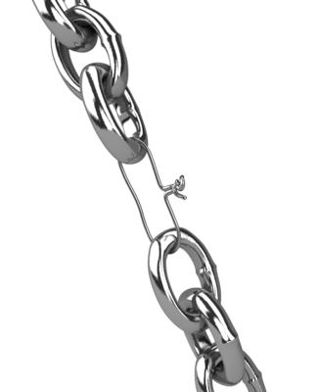

WHO SHOULD ATTEND?

Agents of change

Business managers

Business Architects

Systems Architects

Performance Analysts

Project managers

Technology Professionals

CONTENT/HIGHLIGHTS

P++ and Dr. Serry backgrounds

Meet the stakeholders

Performance challenges

Complexity of enterprise performance management

Performance myths

Back to basics - Performance fundamentals

6x4 Methodology

Show & Tell - P++ modeling tools

Case study - A tale of two banks

Bring your performance issues to the workshop

Call to action

WHAT YOU WILL LEARN?

Enterprise performance is a business not a technology “thing”

Performance myths, are just that!

Simple back-of-the-envelope calculations will give you amazing insights!

Modeling and predicting enterprise performance across business and technology layers is not rocket science! It just a little bit of science and a lot of art

Assessing performance impact of different business/technology architectural scenarios is possible and doable throughout the solution life cycle including early brain storming/white boarding sessions.

Managing enterprise performance can be done efficiently and effectively

You, no longer need to wait till the 11th hour to discover hidden performance issues

Modeling tools need not and should not be expensive

Your organization need to have/develop a performance culture

WHAT YOU ACHIEVE

Demystify performance myths

See the road ahead

Build the confidence to start your own performance journey!

IN-HOUSE WORKSHOP

Customized to your industry, specific performance issues/concerns you might have, and workshop participants

Comes with two 45-minute Business/Technology executive sessions
REGISTER TODAY

SAMPLE OF WORKSHOP SLIDES

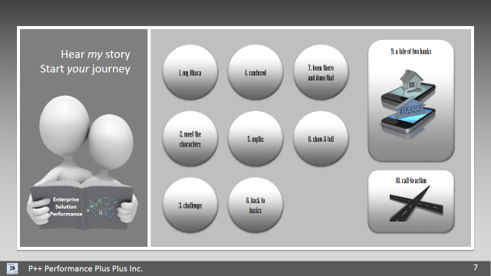 | 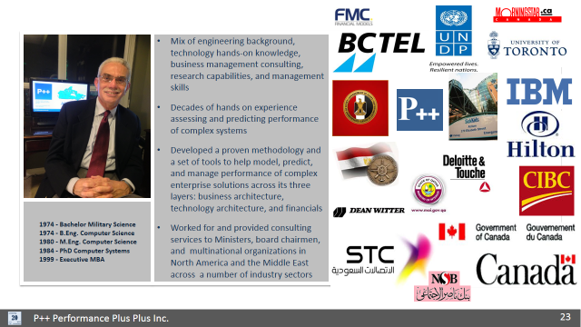 | 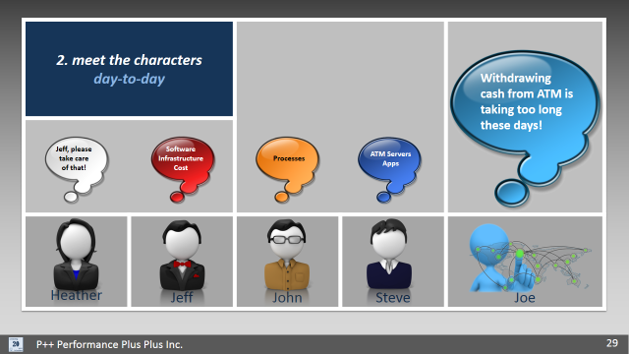
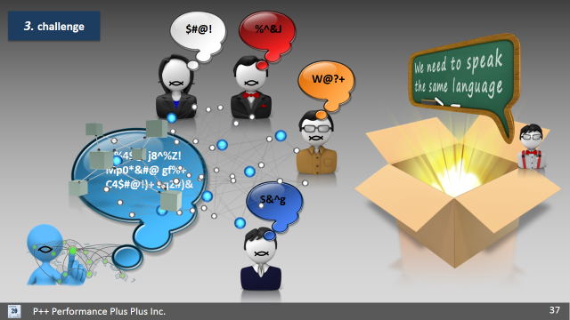 | 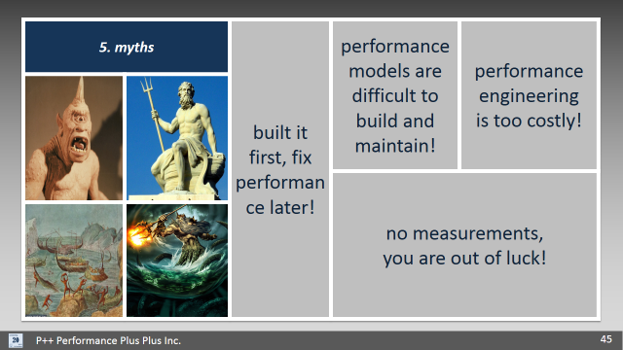 | 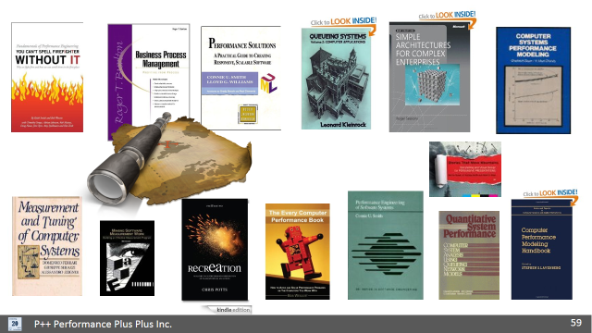
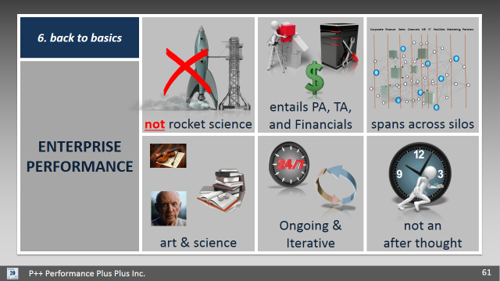 | 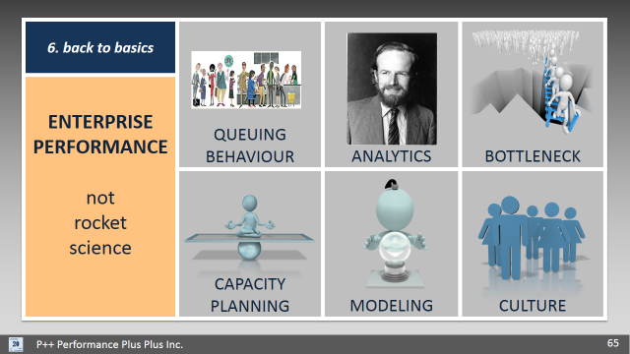 | 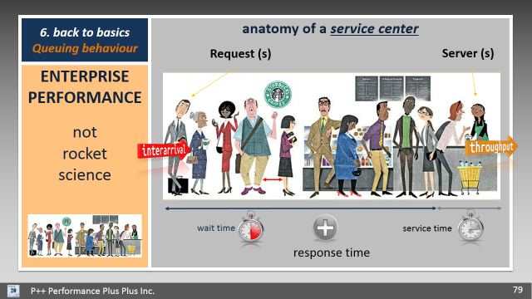
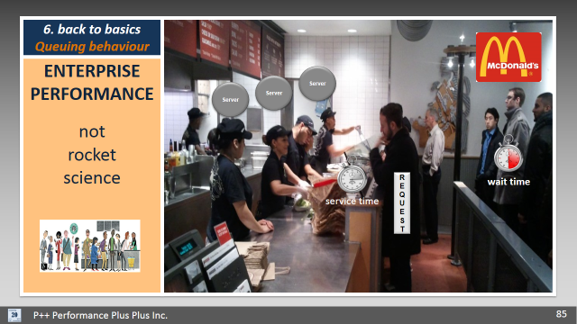 | 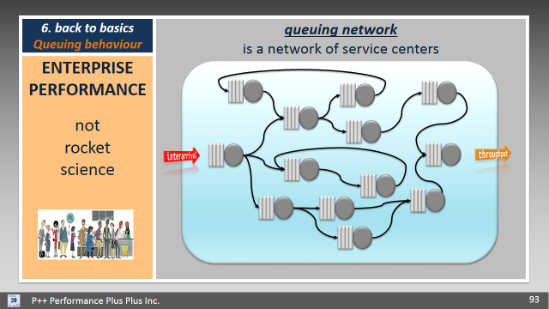 | 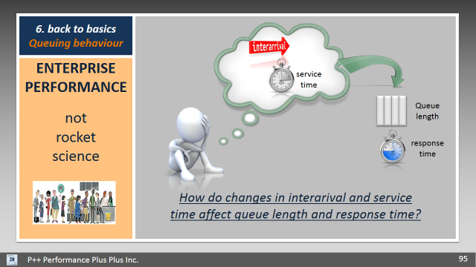
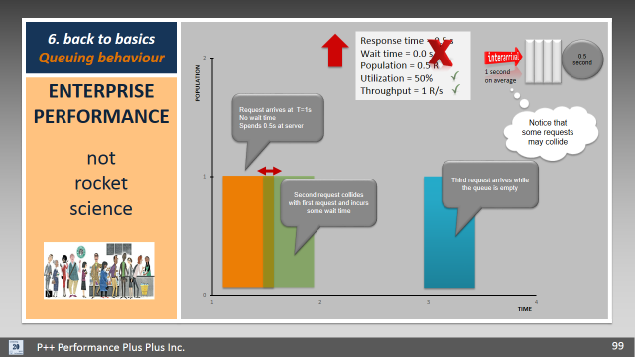 | 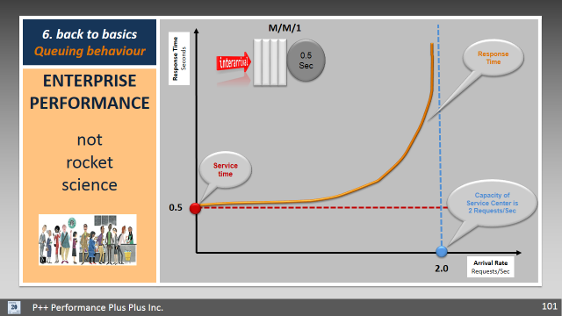 | 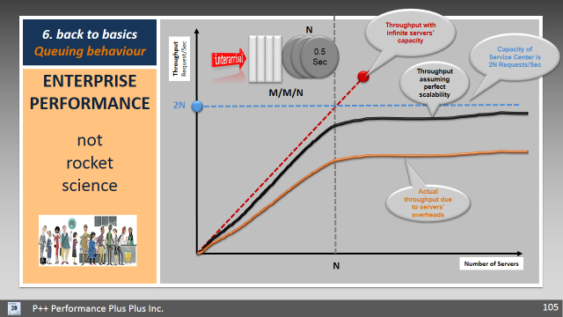
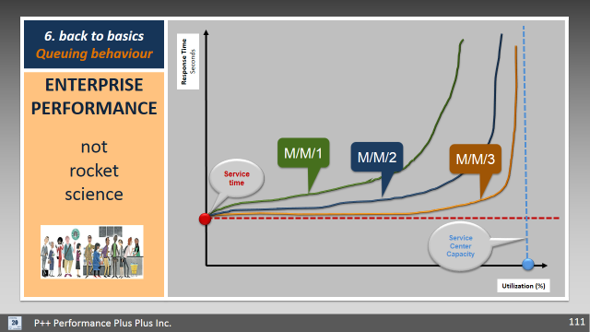 | 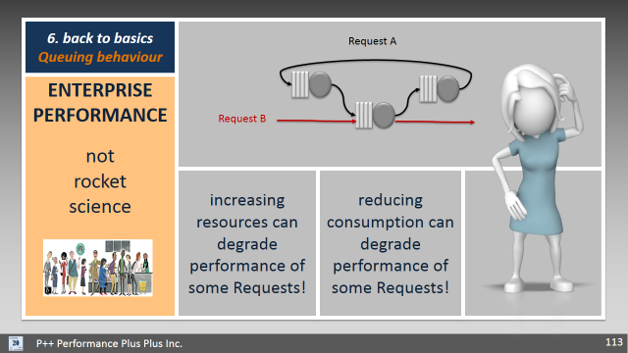 | 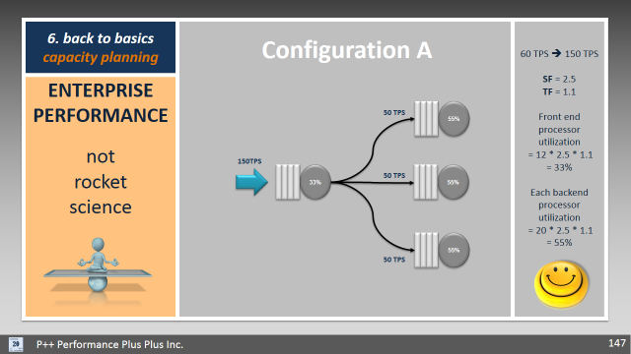
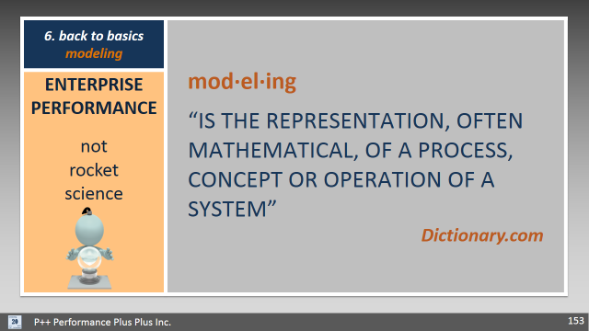 | 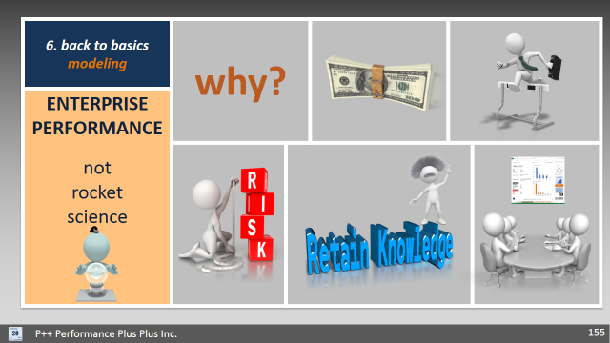 | 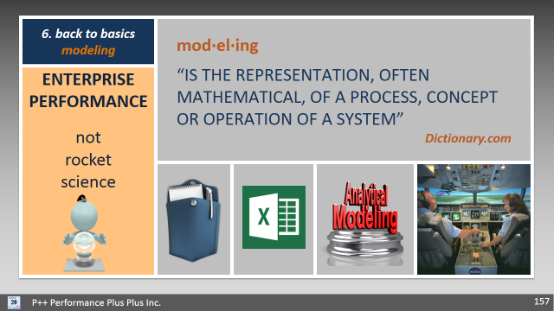

SAMPLE OF WORKSHOP SLIDES (Continued)

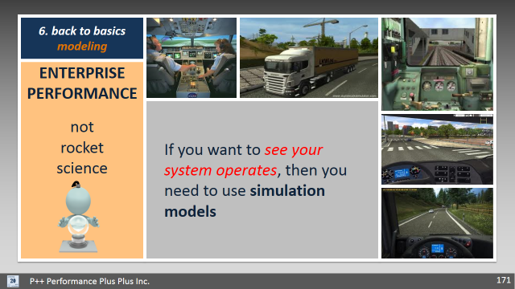 | 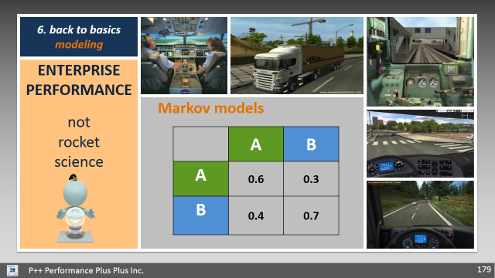 | 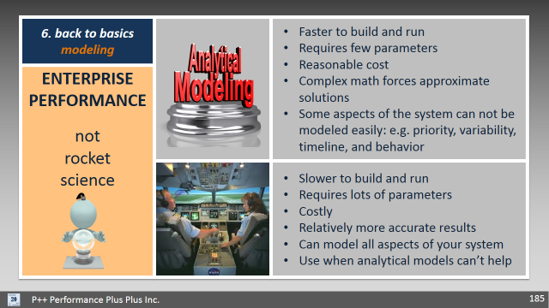
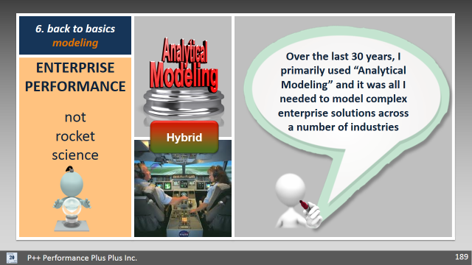 | 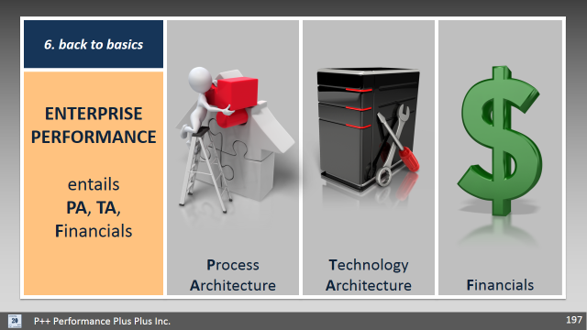 | 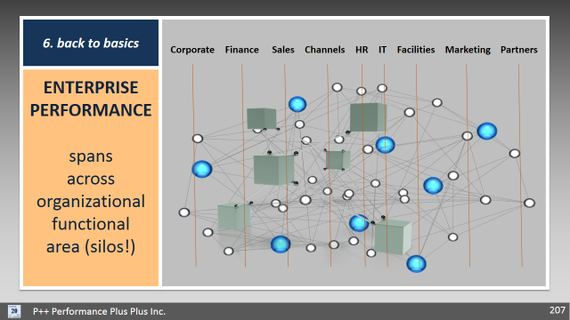
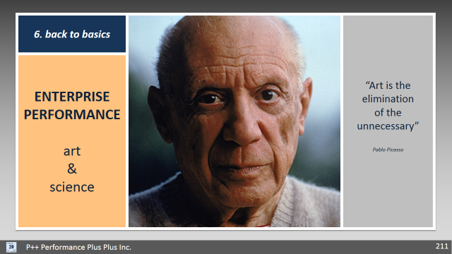 | 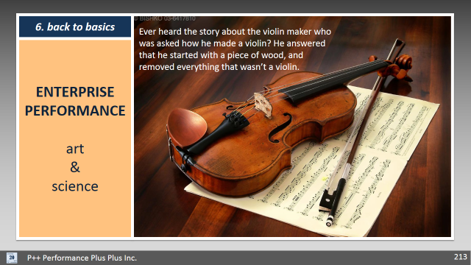 | 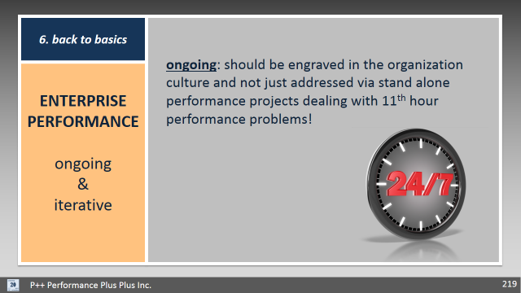
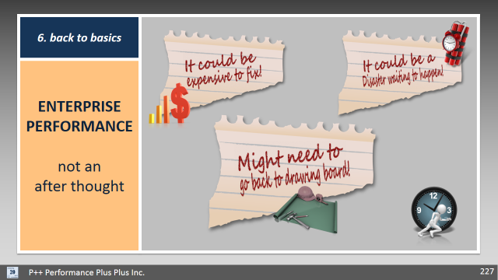 | 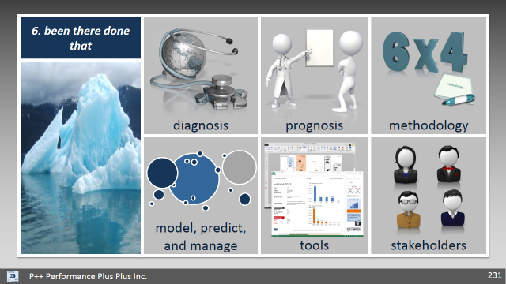 | 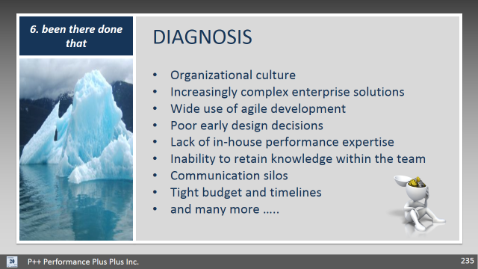
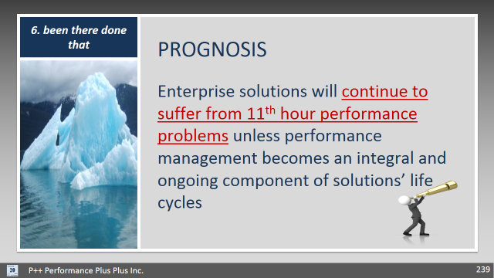 | 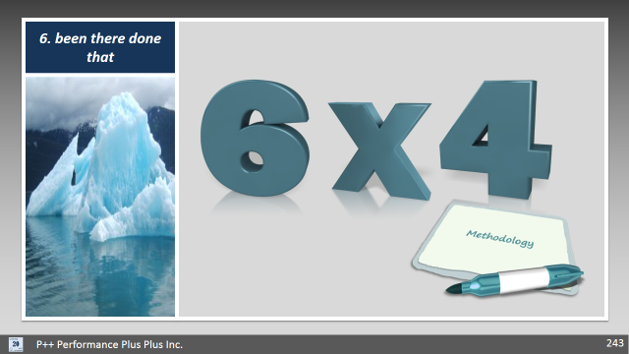 | 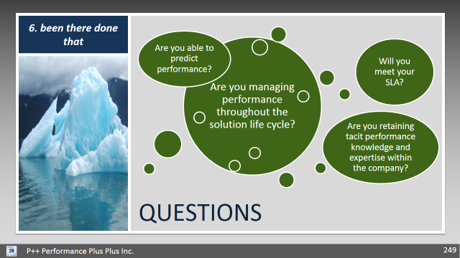
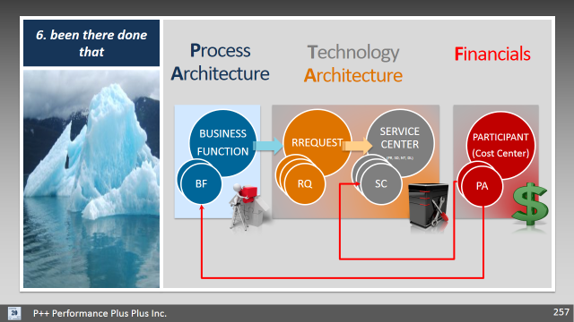 | 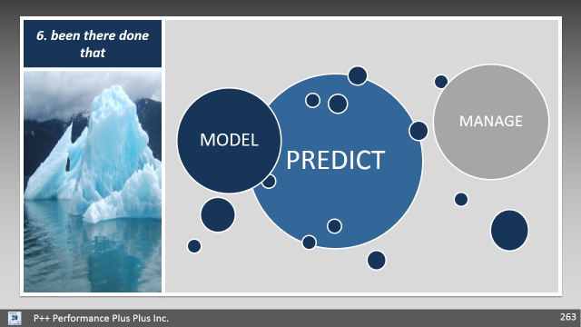 | 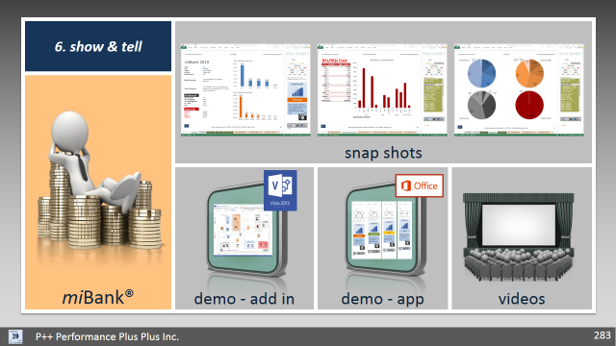
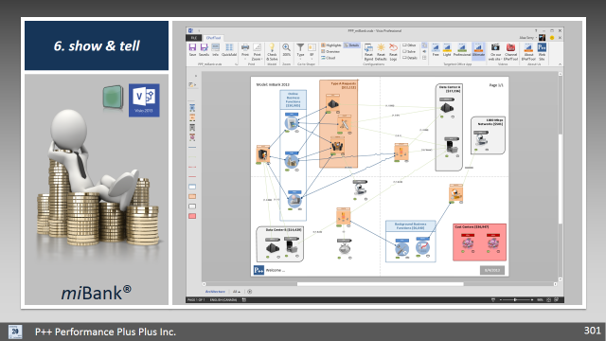 | 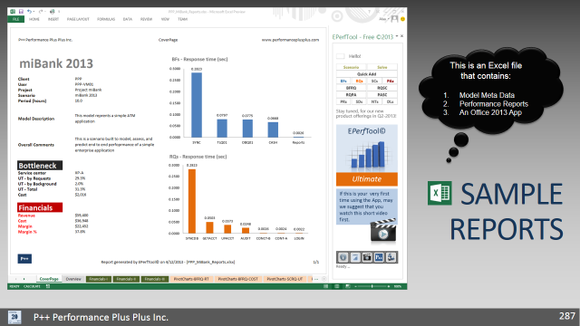 | 